Policy Engagement Training in Humanities and the Social Sciences
A new short course, March-April 2016, with ongoing support

This innovative course enables scholars at to maximise the impact and reach of their research. It provides the skills and confidence to engage with, and influence, public policy and popular audiences. The course is open to scholars working in Higher Education institutions, and in any department, centre or institute, including history, area studies, modern languages, and the social sciences. Participation is suitable for scholars at any stage of their career beyond Masters studies, from PhD students approaching completion to senior staff. The course is offered by History & Policy, the experts in policy engagement for historians, based at the Institute of Contemporary British History at King’s College London.
For more than a decade, H&P has provided professional support for historians seeking to engage with and influence public policy audiences, and has run over many events across central government, including in the Home Office, the Treasury, the Department for Communities and Local Government, the Cabinet Office, the Department for Environment, Farming and Rural Affairs, and No. 10 Downing Street.
Of the 40 places available on this course, 5 will be supported by AHRC bursaries. Applications are welcome from scholars in any humanities or social science university department, centre or institute, including history, area studies, modern languages, and the social sciences, and at any stage of their career from final year PhD to senior academic. Each AHRC bursary will cover the cost of the course (£300pp) which includes two workshops (with refreshments) and ongoing support through 2016. All other costs – such as travel and accommodation, if required – are the responsibility of the participant or his/her institution to cover.
The closing date for applications for the AHRC bursaries is 17th Jan 2016.
During the course, participants will be offered support and guidance in
- Pinpointing and communicating succinctly and accessibly the policy relevance of their research
- Identifying appropriate policy audiences to target and keeping abreast of ‘competing’ voices
- Achieving two-way dialogue and meaningful engagement with policy audiences, rather than just disseminating research
- Monitoring and evaluating the impact of their engagement, and adapting their strategy accordingly
All participants will develop a policy paper and action plan for influence (identifying key messages, audiences and techniques for reaching them) by December 2016. This is a bespoke course, devised and organised by H&P. It draws on the experience we have gained through running other similar training events, described positively by participants:
A really engaging and highly experimental event that took students out of their comfort zone while still utilising their historical skills. It was also a great privilege to see well-known speakers in a stimulating environment and provided me with exposure to a great work culture, diverse people and professional practice.
By creating an informed and dynamic environment, supported by excellent speakers, this event helped me connect my historical research and perspective to real policy areas. I went away not only with a renewed enthusiasm for my own work, but a clear understanding of its potential to influence policy.

Participants from similar courses have gone on to work with BBC TV and radio programmes, teach history in secondary schools, engage with public bodies such as the Parliamentary Office of Science and Technology, and political parties such as the Scottish National Party. Participants have also published their work with History & Policy.
Participants' policy papers and action plans for influence will be submitted to the AHRC as part of the evaluation of the course.
Applicants must complete form below, explaining your motivation for attending the course, your research interests and how you they envisage the policy relevance and public engagement of your research. If registered as a PhD student, please state the length of time in studies and ask your supervisor to confirm he/she supports your participation in this course, by emailing historyandpolicy@kcl.ac.uk by 17 Jan 2016.
AHRC bursaries will be awarded based on aptitude for public policy engagement, relevance of research, and experience to date working with policy makers and shapers. The bursaries will cover the £300 fee for the course, which comprises two day-long workshops and ongoing mentoring. Please note there is no support for travel, accommodation or subsistence costs, which are the responsibility of applicants. By signing up for the course, participants are committing to attend all three workshops and completing the associated written tasks. Please submit your application to historyandpolicy@kcl.ac.uk, by 4pm on 17 Jan 2016.

Programme:
The course will comprise two workshops, held between March and April 2016:
Workshop 1: Introduction to public policy engagement (March 2016)
Lessons from H&P's experience engaging with policy makers and shapers will feature through case studies of effective interventions by humanities and social sciences academics in the public policy process. Through group exercises and individual tasks, participants will practice preparing their research for dissemination and application in policy making. Sir John Chilcot has agreed to participate in this workshop on the theme of ‘responses to terrorism’.

Workshop 2: Public policy engagement – practice & actors (April 2016)
This workshop will consider the landscape of public-policy making in Britain, and the key actors in these processes. Through panels with academics, civil society actors and policy makers, as well as tasks to develop skills, participants will develop greater understanding of the opportunities for intervention and practise their capacities to do so.
----------
Ongoing skills development (April 2016 – Dec 2016)
Editorial advice and support will be provided to develop and finalise participants' H&P policy papers. After this process H&P will select a small group of participants for further support and skills development, based on the viability and relevance of their research for contemporary policy making and shaping.
This subset will be invited, where relevant, to shadow historians in the H&P network, meet with policy makers to discuss areas of common interest, and attend or participate in H&P events in government. Communications advice and training will be given on seeking media coverage for research, and refining a SMART action plan for policy impact.
Overall, the course will provide participants with a greater understanding of public policy making in Britain, and the opportunities and challenges of engaging history in that process. It will equip scholars with greater confidence and skills to enable them to shape the public agenda and enhance their prospects of completing an impact case study in future REF rounds.
Policy Engagement Training is enabled by King’s Policy Institute, the School of Arts & Humanities at King's College London and the AHRC
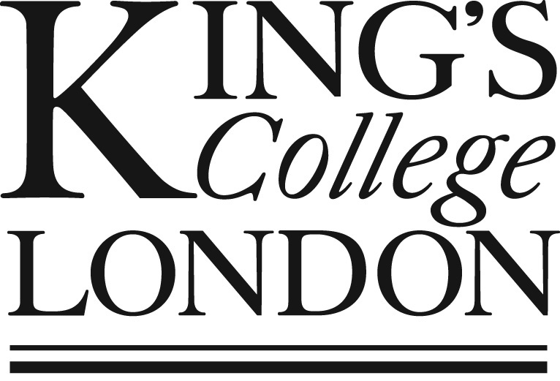

Name and title
Institutional affiliation (if any)
Contact details
Status (permanent staff, postdoc, student etc.)
If PhD student, length of time in studies

Please explain your research interests as if speaking to a non-specialist, in no more than 150 words
Why do you want to attend this course? (max 200 words)
Explain how you think your work could be of interest to policy makers and shapers (max 300 words)
Describe any previous engagement with policy makers and shapers (max 300 words). This could include talking to civil servants or civil society practitioners about your work, participating in their events or writing / contributing to their publications
I confirm that my institution has agreed to meet my travel costs should my application be successful | Yes/ No

Signed:
(Type your name for emailed applications)
Date:

