Policy Impact Skills for Historians
A new short course, Jan-May 2014, with ongoing support

This innovative course enables historians at to maximise the impact and reach of their research. It provides the skills and confidence to engage with, and influence, public policy and popular audiences. The course is open to those working with historical themes and methodologies, across all Higher Education institutions, and in any department, centre or institute, including literature, area studies, modern languages. The course is suitable for historians at any stage of their career beyond Masters studies, from PhD students approaching completion to senior staff. The course is offered by History & Policy, the experts in policy engagement for historians, based at the Institute of Contemporary British History at King’s College London.
For more than a decade, H&P has provided professional support for historians seeking to engage with and influence public policy audiences, and has run over 25 events across central government, including in the Department for Education, the Treasury, the Department for Communities and Local Government, the Cabinet Office, the Department for Environment, Farming and Rural Affairs, and No. 10 Downing Street.
Of the 30 places available on this course, 5 places are on a fee-paying basis - £450 pp - for historians across the UK. Applicants must be historians, of any period, and at any stage of their career from final year PhD to senior academic. The course fee includes three workshops (with refreshments) and ongoing support through 2014. All other costs – such as travel and accommodation, if required – are the responsibility of the participant to cover. The closing date for applications is Friday 13 December 2013.
Participants will be offered support and guidance in:
- Pinpointing and communicating succinctly and accessibly the policy relevance of their research
- Identifying appropriate policy audiences to target and keeping abreast of ‘competing’ voices
- Achieving two-way dialogue and meaningful engagement with policy audiences, rather than just disseminating research
- Monitoring and evaluating the impact of their engagement, and adapting their strategy accordingly
All participants will develop a policy paper and action plan for influence (identifying key messages, audiences and techniques for reaching them) by December 2014. This is a bespoke course, devised and organised by H&P. It draws on the experience we have gained through running other similar training events, described positively by participants:
A really engaging and highly experimental event that took students out of their comfort zone while still utilising their historical skills. It was also a great privilege to see well-known speakers in a stimulating environment and provided me with exposure to a great work culture, diverse people and professional practice.
By creating an informed and dynamic environment, supported by excellent speakers, this event helped me connect my historical research and perspective to real policy areas. I went away not only with a renewed enthusiasm for my own work, but a clear understanding of its potential to influence policy.

Participants from similar courses have gone on to work with BBC TV and radio programmes, teach history in secondary schools, engage with public bodies such as the Parliamentary Office of Science and Technology, and political parties such as the Scottish National Party. Participants have also published their work with History & Policy.
Applicants must complete the form below. If registered as a PhD student, please state length of time in studies and ask your supervisor to confirm he/she supports your participation in this course, by emailing historyandpolicy@kcl.ac.uk by 13 Dec 2013. By signing up for Policy Impact Skills for Historians, you undertake to participate in the three workshops and complete the take-home tasks.

Programme
The course will comprise three workshops, held between Jan-May 2014:
Workshop 1: Introduction to public policy engagement (22 Jan)
Lessons from H&P's experience engaging with policy makers and shapers will feature through case studies of historians' effective intervention in the public policy process. Through group exercises and individual tasks, participants will practice preparing their research for dissemination and application in policy making. The workshop will also cover the impact strategy of King's College London and the AHRC.

Workshop 2: Public policy engagement – practice & actors (26 Feb)
This workshop will consider the landscape of public-policy making in Britain, and the key actors in these processes. Through panels with historians, civil society actors and policy makers, as well as tasks to develop skills, participants will develop greater understanding of the opportunities for intervention and practise their capacities to do so.

Workshop 3: History in the headlines (14 May)
Featuring senior journalists and communications professionals to explain the challenges and opportunities of using history on air and in print, this workshop will offer a lively and informative insight into how different media operate and the implications for historians. A session will be dedicated to historians' varied use of social media, including Twitter.
----------
Ongoing skills development (June 2014 – May 2015)
Editorial advice and support will be provided to develop and finalise participants' H&P policy papers. After this process H&P will select a small group of participants for further support and skills development, based on the viability and relevance of their research for contemporary policy making and shaping.
This subset will be invited, where relevant, to shadow historians in the H&P network, meet with policy makers to discuss areas of common interest, and attend or participate in H&P events in government. Communications advice and training will be given on seeking media coverage for research, and refining a SMART action plan for policy impact.
Overall, the course will provide participants with a greater understanding of public policy making in Britain, and the opportunities and challenges of engaging history in that process. It will equip historians with greater confidence and skills to enable them to shape the public agenda and enhance their prospects of completing an impact case study in future REF rounds.
Policy Impact Skills for Historians is enabled by King’s Policy Institute, the School of Arts & Humanities at King's College London, and the AHRC
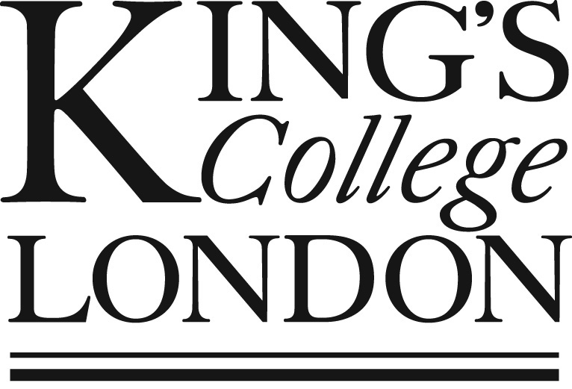

Name and title
Institutional affiliation (if any)
Contact details
Status (permanent staff, postdoc, PhD student etc.)
If PhD student, length of time in studies

Please explain your research interests as if speaking to a non-specialist, in no more than 150 words
Why do you want to attend this course? (max 200 words)
Explain how you think your work could be of interest to policy makers and shapers (max 300 words)
Describe any previous engagement with policy makers and shapers (max 300 words). This could include talking to civil servants or civil society practitioners about your work, participating in their events or writing / contributing to their publications
I confirm that I or my institution can meet my travel costs should my application be successful | Yes/ No

Signed:
(Type your name for emailed applications)
Date:

